Assignment 1

1. Shortest path

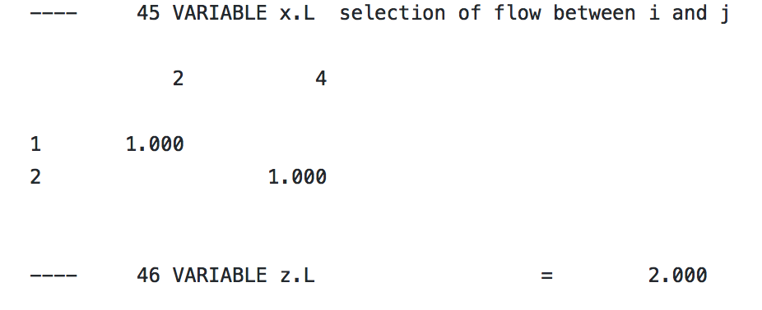

1. Transportation Problem

